Towards a more sustainable food system

Evaluation of Food Matters

A food system literacy course conducted by

The Food Embassy Inc.

2021

2021

Evaluation undertaken by Flinders University Department of Nutrition & Dietetics

Assoc. Prof. Kaye Mehta¹, Dr. Sue Booth^{1, 3}, Carolyn Dent², Chris Arbon², Dr. Carly Moores¹
1 Nutrition & Dietetics, Flinders University; 2 Uniting Care Wesley Bowden; 3. Public Health, Flinders University.

Evaluation undertaken by Kaye Mehta, Mattea Palombo and Liz Sanders.
Report prepared by Kaye Mehta.
We thank respondents for their generous participation in this evaluation.
We also thank Green Adelaide for funding this evaluation and for the City of Onkaparinga and City of Marion councils for their funding support in running the Food Matters courses.
Copies available at https://www.thefoodembassy.org/
For more information contact: Liz Sanders, Email: liz@thefoodembassy.org

Executive Summary

- The Food Embassy Inc. (TFE) delivers Food Matters (FM) a basic education course with objectives to increase participants’ understanding about the food system and their confidence to engage in sustainable eating. From interviews and focus groups with participants of the course, it appears that the course not only meets its objectives but also contributes to the broader goal of TFE to build local food communities. Within the bounds of a short course, the pedagogy of FM enables participants to engage with the complexity of the food system and be inspired to contribute to changes needed. At this time of climate crisis and with the food system needing to be part of the solution, a course like Food Matters plays an important role in building public awareness and support for change.

- The food system is widely considered to be ‘broken’ with climate change, environmental damage and population health problems as a consequence. Experts have called for a ‘Great Food Transformation’ which will require policy reform as well as public education. Current levels of food system literacy in the general population is acknowledged as being low and inadequate to the task of bringing about the required social change.

- Sustainable eating will be an important part of addressing food system problems by: reducing consumption of animal products and processed foods; increasing consumption of vegetables and fruits; limiting food waste; and, buying seasonal and local foods. Sustainable eating will require raising public levels of food system literacy.

- The Food Embassy (TFE) is a not for profit incorporated business committed to connecting community through food and building local food communities. TFE developed and delivers Food Matters a basic education course that increases participants’ understanding about the food system and their confidence to engage in sustainable eating. The course uses adult education principles that emphasise respectful relations, experiential learning, action planning and building a learning community.

- Earlier evaluations of the Food Matters courses have found positive changes in knowledge, attitudes and behaviours towards supporting a more sustainable food system. This report describes a deeper qualitative evaluation of the FM courses to understand the knowledge, attitudinal and behavioural impacts on participants, and also to get feedback about the course.

- Participants were those who had attended face-to-face and online FM courses during 2019 and 2020. Nine people participated in focus groups and 3 people participated in phone interviews, which were conducted between June and September of 2020.

- Participants reported that they learnt many things that were useful for eating more sustainably and supporting a more sustainable food system. At a broader level they appreciated learning about the complexity the food system. Analysing the food system is no mean feat as it is a complex network of multiple elements, processes and inter-relationships. It is heartening that in spite of the challenges of developing a short course on the food system, participants came away satisfied with learning new and complex knowledge.

- Participants also reported new ways of thinking about food. They reflected critically about the food system and their own food choices; they thought more about the ethics of food purchases and wanted to use their food-money to support local food producers.

- Most participants made changes to their food behaviours towards more sustainable eating: consuming less meat and processed foods; consuming more plant foods; cooking from scratch; gardening and composting; buying local foods; and, minimising food waste.

- Some participants joined social groups involved in food preserving, gardening or food swaps, while others made contributions to their local communities, for example sharing their knowledge, starting local gardening groups, and advocating for more trees in the neighbourhood.

- Participants were unanimously satisfied with the Food Matters course and how it was run. Specifically, they commended the course for providing a framework for thinking about food, creating an inspiring and empowering environment for learning, and, enabling a community of learners and food citizens.

- The findings affirm a number of methodologies employed by the FM course: the new ways of thinking reported by participants affirm transformative educational methodology; the inspiration reported by participants and the numerous changes they reported at an individual and community level, affirm empowerment education methodology.

- The inclusion of Indigenous food history and knowledge through the guest speaker component of the curriculum is not only novel in food based education but also important in respecting Indigenous sovereignty and wisdom in food and land management.
Contents
Executive Summary 2
1. Background to Food Matters course 5
Why do we need food system education? 5
What can individuals do? 5
Food system literacy and Food Matters 7
Evaluation method 8
Key findings 9
New knowledge 9
New ways of thinking 9
New behaviours 10
Feedback of FM course 11
Discussion 13
Food system education 13
Food citizenship 14
Education methodology 15
Conclusion 16
References 17

Background to Food Matters course

Why do we need food system education?

The food system is a complex network of multiple elements, processes and inter-relationships spanning production, processing, packaging, distribution, consumption, and waste (Widener and Karides 2014, Mason and Lang 2017). The food system is widely considered to be ‘broken’ and evidence of this includes: a highly dominated industrial food system contributing to destabilisation of food production economies; greenhouse gas emissions, climate change, loss of biodiversity, excessive water use, soil erosion and chemical pollution destroying the environment; and, rising rates of obesity and diet-related diseases (Lawrence and Friel 2019, Willett, Rockström et al. 2019).

A systems approach is essential to solving the current suite of complex food-related problems because it enables consideration of the breadth of influencing factors including economic, political, environmental, health, social, and cultural factors that mutually interact with, and influence each other to ultimately impact the health and wellbeing of communities, their economies and their environments (Wilkins, Lapp et al. 2010, Pieniak, Żakowska-Biemans et al. 2016, Sustain 2017, Willett, Rockström et al. 2019). In fact, Willett et al (2019) call for nothing less than a ‘Great Food Transformation’ to change the dire situation we find ourselves in and they suggest that as well as policy reform, public education is also required to address food system problems.

Food system literacy is acknowledged as a gap and hinderance to bringing about social change (Sustain 2017). Food system education could address the gap in understanding complex social and health problems from a systems perspective (Kirveennummi, Mäkelä et al. 2013, Rebrovick 2015). Community based education can empower citizens to become informed, build partnerships, change behaviours, and advocate for a more sustainable future (Tilbury and Wortman 2008). In this way people move from being passive consumers to active food citizens engaged in food democracy exercising their rights to a food system that promotes health for all and protects the environment (Lang 2005). | 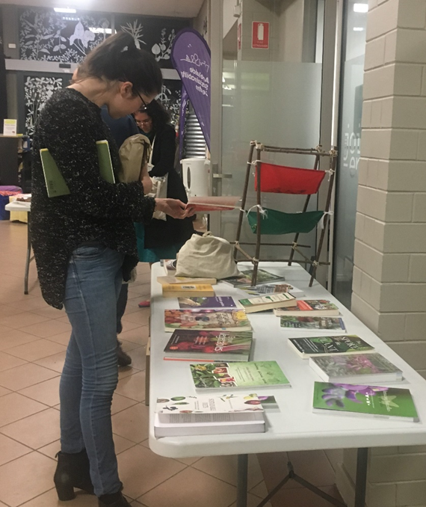

What can individuals do?

Individual level change primarily takes the form of sustainable food choices which constitute: reducing consumption of animal products and processed foods; increasing consumption of vegetables and fruits; limiting food waste; and buying seasonal, local and organic foods (Springmann, Wiebe et al. 2018, Willett, Rockström et al. 2019). Sustainable eating is positioned as an important part of addressing food system problems resulting in poor health as well as, environmental degradation (Willett, Rockström et al. 2019), and in fact, would deliver dual benefits to individual health as well as environmental protection (Springmann, Wiebe et al. 2018). Promoting sustainable eating requires a degree of food system literacy so that consumers understand the relationships between their food choices and environmental, health and social outcomes (Wilkins, Lapp et al. 2010, Willett, Rockström et al. 2019). Gaining skills in food system literacy would enable citizens to understand the complex issues and inter-relationships within the food system, and to engage in collective as well as individual action for change (Hess and Trexler 2011, Sykes, Wills et al. 2013). In fact, food democracy would encourage moving beyond individual action for self-interest to collective action in the interests of public good (Hassanein 2008, Booth and Coveney 2015).

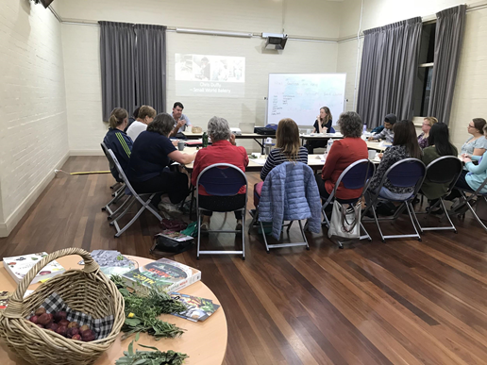

Food system literacy and Food Matters

The Food Embassy Inc. (TFE) is a not for profit incorporated business that was co-founded in 2016 by Liz Sanders. The key vision of the business is to connect community through food and to build local food communities. TFE partners with a range of community organisations to deliver Food Matters courses in collaboration with community organisations such as local governments, Green Adelaide, SA Urban Food Network and Adelaide Sustainability Centre.

The FM is a short course that examines the food system through four lenses: economic, environment, social and health.
The course objectives are:
- To increase participants knowledge of a local, sustainable food system considering, social, economic and environmental factors.
- To increase confidence in engagement with the local food system.
- To improve attitude to sustainable food choices
- To encourage personal and community action around local food systems.

Each session follows a similar format and included provision of information using a range of audio-visual formats and guest speakers, discussions, sharing of skills and information, and action planning. Whilst each course responded uniquely to the interests of the participants, all courses nevertheless consistently addressed environmental, economic, social and health aspects of the food system. Specific topics included: industrial and local food systems; sustainable eating; regenerative food production; biodiversity; and, food access and equity.
Guest speakers linked participants directly with producers, environmentally sustainable practices and personal experiences. The final week included a specific session on taking action using a food democracy framework. Small groups were formed to look at 3-4 projects based on a range of topics identified during the previous three weeks. With the onset of COVID-19, the course went through a number of changes to accommodate social distancing; it was delivered online and into an event-style format.

Evaluation of the Food Matters courses has found positive changes in knowledge, attitudes and behaviours towards supporting a more sustainable food system (The Food Embassy 2020). This report describes a deeper qualitative evaluation of the FM courses to understand the knowledge, attitudinal and behavioural impacts on participants, and also to get more feedback about the course. The work was led by members of the Food Embassy, Kaye Mehta, Liz Sanders and Mattea Palombo.

Evaluation method

Participants were those who had attended face-to-face and online FM courses during 2019 and 2020. Due to the COVID 19 pandemic, the FM courses were delivered with a mix of face-to-face and online methods, depending on the social distancing policies that were constantly changing over that year. All past participants were sent an email from the course coordinator (LS) with information and an invitation to take part in the evaluation. People registered their interest by email and could ask further questions of the course coordinator. All participants provided written consent to take part in the evaluation. Ethics approval was received from the Flinders University Social and Behavioural Research Ethics Committee.

The evaluation employed qualitative methods to gain a deep understanding about the impacts of the Food Matters course on participants. The evaluation enquired into changes in knowledge, attitudes and behaviours; barriers to making changes; supports required; and feedback on the FM course. A copy of the interview questions can be obtained from kaye.mehta@flinders.edu.au.

The preferred evaluation method was focus groups in order to capitalise on the informal and conversational environment that can be achieved by this method (Bloor 2001). Due to COVID19 the first focus group was held using the Zoom discussion platform and the second focus group was held face-to-face with appropriate social distancing which was permitted in South Australia. Due to the difficulties in coordinating focus group attendance, the final perspectives were collected via phone interviews. The first focus group was conducted by KM and MP, and the second focus group and remaining interviews were conducted by MP. While each of these methods has its own strengths and weaknesses, the verbatim transcripts revealed consistent and appropriately rich information. The transcripts were coded and analysed thematically with involvement from all members of the research team. | 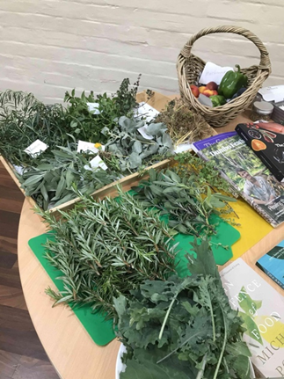

Key findings
Nine people participated in focus groups and 3 people participated in phone interviews, which were conducted between June and September of 2020.

Participants spoke about knowledge they gained from the FM course, new ways of thinking, actions they had taken, and barriers to taking action. They also provided feedback about the FM course.

New knowledge
Participants learnt many things that were useful for eating more sustainably and supporting a more sustainable food system. At a broader level they learnt about the complexity the food system.

ahh how complex it [food system] is … you just don’t walk into a supermarket and bang! there’s your food, there are so many hands … especially if you are buying from a big supermarket; so many parties that take part in that piece of fruit or vegetable getting on your plate in the kitchen. It’s unreal. R11

A novel aspect of the course was Indigenous foodways and bush foods.  probably the most important part for me was the whole session on Indigenous food knowledge um, and that was um, something that was really like, while the other things are things that I had tended towards, and had a critical mindset towards before, the Indigenous food knowledge system was something that I like, I had no knowledge of and so really built it from zero. R6 | 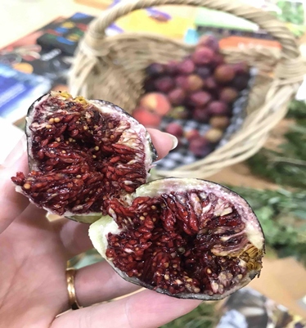

New ways of thinking
They reflected critically about the food system and their own food choices; they thought more about the ethics of food purchases and wanted to use their food-money to support local food producers.

the course made me think a lot more um, about the ethics of food and the way food is produced and that is something that I hadn’t really thought about before … I’m buying from suppliers that I know and I know that it is produced properly and people are paid properly to produce that food, that was just something new for me. R1

New behaviours
Most participants made changes to their food patterns towards more sustainable eating consuming less meat and processed foods, consuming more plant foods, cooking from scratch, gardening, composting, buying local foods and minimising waste.

especially with vegetables we have cut down on meat which is really good. R7

Some people joined social groups engaged in food preserving, gardening or food swaps.

R5 and I were part of a little group where we all got together at my house and I had an orange tree at the back of my house that was heavy with oranges and we spent a day picking the oranges and making them into marmalade using R5’s grandmothers recipe and so that was fantastic. R6

Others made contributions to their local communities, for example sharing their knowledge with friends and family, starting local gardening groups, and advocating for more trees in the neighbourhood.

with another lady who did the Food Matters course we both went and learnt Magic Harvest coordinators’ program and we have started a Magic Harvest group here in Willunga which is where I live. … directly as a result of me attending the Food Matters course [be]cause I happened to be at the Food Matters course with a member from Council … that’s been a big thing because its been a lot of time but also very enjoyable so that’s been my community action. R1

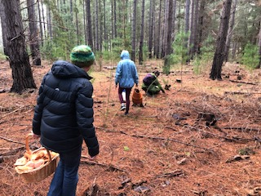

Feedback of FM course
Participants were unanimously satisfied with the Food Matters course and how it was run.

Specifically, they commended the course for providing a framework for thinking about food, creating an inspiring and empowering environment for learning, and, enabling a community of learners and food citizens. Guest speakers were highly valued.

I think you can feel overwhelmed but for me it was more about empowering me, you know, ‘you can make a difference and you can have some power over your food choices and where you buy and what you buy and how much you buy,’ all of those sorts of things. I think it was good, I think the Food Matters course had quite a focus on action that you can take and for me that was quite positive in empowering. R10

They found the content and delivery of the program to be of high quality. In particular, they appreciated the multi-modal and experiential methodology to enable deep and enjoyable learning.

it was that sharing table that really got people talking, you know if you grow something and you take something home. I was always taught that that was a good presentation thing to do as well you know you give people the information in lots of different forms, you get them talking have some input from them and then you give them something to take home and I did that lots of times after. R9

Participants highlighted the value of guest speakers who provided inspiration for a more sustainable food system as well as, practical links to purchasing local foods.

I loved hearing from the local farmers and producers I think we had Small World bakery … like hearing from local farmers and producers on the round R10

They had some suggestions for improvement. Some people wanted more and these mostly related to wanting more educational input, follow-up and support for the new actions they were taking.

If they had a refresher you know 6 months down the track try and see if everyone wants to come together again whether that was a one or two session thing, it’s like a support group really you can go along … you can’t just go and learn it and then you’ve got your survival kit, you know it’s an ongoing thing and listening to other people and what they do and what works for them and sharing your ideas with them , yeah I guess it’s like a support group. R11

Involvement of local Councils was seen as essential to support on-going food sustainability endeavours.
I think it comes down to the Council maybe we could communicate with the Council so, that it would be easier for people who wants to grow their own vegetables; for people who don’t have their own garden. For example I live in an apartment building so we don’t have that kind of frontier to grow, so people who live in apartments maybe they can have some connection with the Council so that they can look at having some sort of land to grow or rent land or make community garden more accessible for more people. R2
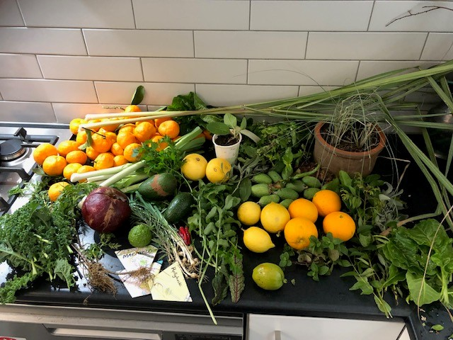

Discussion

The qualitative interviews and focus groups revealed that participants came away from the Food Matters course with considerable knowledge about the food system and sustainability, as well as, new ways of thinking about the food system and their role as food consumers. They had taken steps to improve their personal food behaviours towards more sustainable eating, and some of them had extended their sustainability actions into the community. The impacts cited by participants confirm that the Food Matters course achieved its stated objectives. Participants reflected positively on the course ascribing to it the impact of inspiring and enabling their efforts towards ethical food citizenship. They commended the content, format and delivery of the curriculum. They hoped for on-going support in their sustainable eating efforts and saw their local Council as playing a key role in assisting them to achieve their aspirations.

Some important ideas emerging from the evaluation are: food system education; food citizenship; and, education methodology.

Food system education

Participants reported that they learnt many things that were useful for eating more sustainably and supporting a more sustainable food system. At a broader level they appreciated learning about the complexity the food system.

Food system education has been posited as a necessary part of assisting the public to understand the environmental, social and health problems associated with the food system, and be empowered to take personal and collective action for change (Rebrovick 2015, Baker and Demaio 2019, Willett, Rockström et al. 2019). Understanding the food system is no mean feat as it is itself a
complex network of multiple elements, processes and inter-relationships spanning production, processing, packaging, distribution, consumption, and waste (Widener and Karides 2014, Mason and Lang 2017). The Food Matters course attempted the challenging feat of examining the food system, albeit in a bounded way, through three lenses of economic, environment and social/health. It is heartening that in spite of the difficulties of developing a sound albeit short course on the food system, that participants came away with a perception of gaining new knowledge.

Food citizenship

As well as acquiring new knowledge, participants also reported new ways of thinking about food. They reflected critically about the food system and their own food choices; they thought more about the ethics of food purchases and wanted to use their food-money to support local food producers. Proponents of citizen engagement in food system reform suggest that ethical as well as pragmatic reflection is necessary to bring about change (Timotijevic 2019).

Most participants made changes to their food patterns towards more sustainable eating; consuming less meat and processed foods, consuming more plant foods, cooking from scratch, gardening, composting, buying local foods and minimising waste. Sustainable eating is an important part of individual-level changes for addressing food system problems (Springmann, Wiebe et al. 2018, Willett, Rockström et al. 2019), and food system education is necessary to foster these changes (Wilkins, Lapp et al. 2010, Willett, Rockström et al. 2019). Engaging citizens also needs to go beyond individual change and include political empowerment to engage in whole-system change (Lawrence and Friel 2019).

Some participants joined social groups involved in food preserving, gardening or food swaps. Others still, made contributions to their local communities, for example sharing their knowledge with friends and family, starting local gardening groups, and advocating for more trees in the neighbourhood. This kind of civic contribution, reciprocity and connectedness has been called social capital which contribute to social and economic well-being of communities and societies (Cuthill 2003). This collective action in the public good is also integral to food democracy and the transformation from passive consumers to active citizens acting in the interests of a transformed food system (Hassanein 2008, Booth and Coveney 2015). As well as achieving the stated objectives of course FM can be said to contribute to the broader goal of building local food communities.

The participants in the FM course reported a sense of pride and purpose in sharing their new-found knowledge with friends and family, even though this was not without its challenges. This is not too dissimilar to impacts identified by peer-educators who report growth in knowledge, skills, confidence, self-empowerment, sense of achievement, strengthened self-identity and pride in contributing to the betterment of their communities. (Mehta, Booth et al. 2017) .

Education methodology

Participants were unanimously satisfied with the Food Matters course and how it was run. Specifically, they commended the course for providing a framework for thinking about food, creating an inspiring and empowering environment for learning, and, enabling a community of learners and food citizens. Guest speakers were highly valued. Suggestions for improvement revolved around more educational input as well as, support for the new actions they were taking.

Transformative educational methodology require a critique of the status quo and bring about a change in thinking or consciousness (Elias 1997). Transformative education and the creation of new ways of thinking is essential to the process of engaging citizenry to take personal and collective action for change (Stromquist 2015). The new ways of thinking reported by participants suggest that the FM course fits this methodology.

Community development is a methodology associated with empowerment to the extent that it enshrines principles of capacity building, shared decision making, reciprocity and civic engagement (Laverack, 2006; Rissel, 1994). The inclusive strategies used in the FM course emphasising shared knowledge, building a community of learners and emphasising action, would have contributed to empowerment education.

Indigenous knowledges about sustainable food systems has long been ignored in Australia’s history of colonisation, and there is a correction happening in the integration of these knowledges into sustainability education (Williams 2018). While new to this endeavour, and with few guiding models, save values of cultural respect, the FM course attempted to insert Indigenous food history and knowledge through the guest speaker component of the curriculum, and this aspect received positive feedback from participants.

In all, no single methodology is adequate for empowerment and transformation of participants, but rather an eclectic approach drawing on all available methodologies that enable citizens to analyse complex problems and participate in creating a better food future.
The FM course appears to have achieved this.

Conclusion

From interviews and focus groups with participants of Food Matters courses, it would appear that the objectives to increase participants’ understanding about the food system and their confidence to engage in sustainable eating, have been met. Within the bounds of a short course, the pedagogy of Food Matters enables participants to engage with the complexity of the food system and be inspired to contribute to changes needed to switch to a more sustainable food system. At this time of climate crisis and with the food system needing to be part of the solution, a course like Food Matters is needed.

References

- Baker, P. and A. Demaio (2019). The political economy of healthy and sustainable food systems. Healthy and Sustainable Food Systems.
- Bloor, M. (2001). Focus groups in social research, Sage.
- Booth, S. and J. Coveney (2015). Food democracy: From consumer to food citizen, Springer.
- Cuthill, M. (2003). The contribution of human and social capital to building community well-being: A research agenda relating to citizen participation in local governance in Australia. Urban policy and research 21(4): 373-391.
- Elias, D. (1997). It's time to change our minds: An introduction to transformative learning. ReVision 20(1): 2-7.
- Hassanein, N. (2008). Locating food democracy: Theoretical and practical ingredients. Journal of Hunger & Environmental Nutrition 3(2-3): 286-308.
- Hess, A. and C. Trexler (2011). A Qualitative Study of Agricultural Literacy in Urban Youth: What Do Elementary Students Understand about the Agri-Food System. Journal of Agricultural Education 52(4): 1-12.
- Kirveennummi, A., J. Mäkelä and R. Saarimaa (2013). Beating unsustainability with eating: four alternative food-consumption scenarios. Sustainability: Science, Practice and Policy 9(2): 83-91.
- Lang, T. (2005). Food control or food democracy? Re-engaging nutrition with society and the environment. Public Health Nutrition 8(6a): 730-737.
- Lawrence, M. and S. Friel (2019). Healthy and sustainable food systems, Routledge.
- Mason, P. and T. Lang (2017). Sustainable diets: how ecological nutrition can transform consumption and the food system, Routledge.
- Mehta, K., S. Booth, C. Dent and C. Moores (2017). Selected highlights of evaluation of South Australian Community Foodies program 2015-2016. Flinders University of South Australia.
- Pieniak, Z., S. Żakowska-Biemans, E. Kostyra and M. Raats (2016). Sustainable healthy eating behaviour of young adults: towards a novel methodological approach. BMC Public Health 16(1): 1-9.
- Rebrovick, T. (2015). The Politics of Diet: Eco-dietetics, Neoliberalism, and the History of Dietetic Discourses. Political Research Quarterly 68(4): 678-689.
- Springmann, M., K. Wiebe, D. Mason-D'Croz, T. B. Sulser, M. Rayner and P. Scarborough (2018). Health and nutritional aspects of sustainable diet strategies and their association with environmental impacts: a global modelling analysis with country-level detail. Lancet Planet Health 2(10): e451-e461.
- Stromquist, N. P. (2015). Gender structure and women’s agency: Toward greater theoretical understanding of education for transformation. International Journal of Lifelong Education 34(1): 59-75.
- Sustain, (2017). Cardinia Food Circles. Food systems background and mapping. Sustain, The Australian Food Network.
- Sykes, S., J. Wills, G. Rowlands and K. Popple (2013). Understanding critical health literacy: a concept analysis. BMC Public Health 13(1): 150.
- Tilbury, D. and D. Wortman (2008). How is community education contributing to sustainability in practice? Applied Environmental education and communication 7(3): 83-93.
- Timotijevic, L. (2019). People’s food-related practices to promote healthy and sustainable food systems. In Lawrence, M. and S. Friel (Eds), Healthy and sustainable food systems, Routledge.
- Widener, P. and M. Karides (2014). Food System Literacy. Food, Culture & Society 17(4): 665-687.
- Wilkins, J., J. Lapp, A. Tagtow and S. Roberts (2010). Beyond eating right: The emergence of civic dietetics to foster health and sustainability through food system change. J Hunger Environ Nutr 5(1): 2-12.
- Willett, W., J. Rockström, B. Loken, M. Springmann, T. Lang, S. Vermeulen, T. Garnett, D. Tilman, F. DeClerck and A. Wood (2019). Food in the Anthropocene: the EAT–Lancet Commission on healthy diets from sustainable food systems. The Lancet 393(10170): 447-492.
- Williams, L. (2018). Transformative sustainability education and empowerment practice on Indigenous lands: Part one. Journal of Transformative Education 16(4): 344-364.

